**ABSTRACT**

In metro cities we can see you a huge rush at shopping malls on holidays and weekends. This becomes even more when there are huge offers and discounts. Now a days people purchase a variety of items and put them in the trolley. After total purchasing one should approach counter for billing purpose. By using barcode reader the cashier prepares the bill which is a time consuming process. This results in long queues at the billing counters. This project presents an idea to develop a system in shopping malls to overcome the above problem. To achieve this all products in the mall should be equipped with RFID tags and all trolleys should be equipped with a RFID reader and LCD screen .When one puts any product in the trolley its code will be detected automatically , the item name and cost will be displayed on the LCD, thereby the cost gets added to the total bill. If we wish to remove the product from the trolley, you can take away the product and the amount of that specific product gets deducted from total amount and the same information passes to the central billing unit via Zig Bee module . Hence the billing can be done in the trolley itself thereby saving a lot of time to the customers.

**INTRODUCTION**

Individuals have constantly created innovation to bolster their requirements as from the start of humankind. The fundamental reason for development in innovation is ought for more independency and this leads to improving tasks and making regular one simpler and speedier. One significant task that individuals invest maximum measure of energy is in shopping. Shopping center is a spot where individuals get their everyday necessities running from sustenance items, garments, electrical machines and so forth. Some of the time clients have issues with respect to the unspecific data about the item marked down and misuse of superfluous time at the counters. In this innovative world, each grocery store and supermarkets utilize shopping trolleys with a specific end goal to help clients to choose and store the items which they expect to buy.

Customers usually purchase the products required and place them in their carts and thereafter wait at the counters for payments of bills. The payment of bills at the counters is really troublesome and time consuming process which thereby increasing a heavy crowd at the counters. Purchasing in-individual includes an individual call at location of purchasing and choosing items in view of different variables including need, comfort, brand, and so on. The proposed keen Shopping basket framework plans to help shopping in-individual that will minimize the time spent in shopping.

To beat these issues expressed above and to enhance the current framework, we have composed a Shopping basket. This can be done possible by basically connecting RFID labels to the items and reader with a LCD in the purchasing cart.

From this framework client can possess data related to cost of each thing which are inside cart and furthermore absolute cost of the thing about the item. This framework will save time of clients and labor required in shopping center with respect to cost of the item.

The fundamental motivation behind this system is to show the proposition of a design and arrangement of an inventive framework for obtaining of items in markets . This cart explores rising versatile innovations and programmed recognizable proof advancements, (for example, RFID) as an approach to enhance the nature of administrations given by retailers and to expand the customer esteem consequently permitting to save time and cash. With this cart an excellent opportunity will be developed which assists the customers by showing the catalog of products and their respective costs. This approach thereby helps the inventory management unit with an instinctive upgrade on each purchase of product. This smart cart has the capability to make shopping more relaxable, comfortable and systematic for the customers as well as making easier for the store management .

**OBJECTIVE**

The main objective involved in this plan is to implement a smart shopping cart with the help of RFID technology for improvising purchasing . The plan is to employ the RFID related surveillance implementation practice in the purchasing cart. In this plan RFID card is utilized as protection entry for acquiring of commodities in the Shopping malls. If the commodity has been placed in the shopping cart the price of the product appears and accordingly the total amount will be shown and if we wish to remove the product from the trolley, you can take away the product and the amount of that specific product gets deducted from total amount .In this , the technology used is for obtaining the products thereby which boosts security performance and speed while purchasing in shopping complexes. The technological objective for our presented problem in shopping complexes is the practice of RFID technology for the instinctive recognition of commodity in the interior of the purchasing cart thereby annihilating shopper intervening in the task of commodity purchase and for payment. The principle point of proposed framework is to give an innovation which is minimal effort oriented , effectively adaptable, and efficiently feasible for helping shopping in individual. With the help of this a lot of time will be saved at the billing counters .

**METHODOLOGY**

The proposed system in this thesis will be implemented into two parts . First part is the initialization of the Raspberry Pi for the set up of RFID Reader and Zigbee . Second part is the tag detection of products by RFID Reader which are placed in the cart and sending of product information from cart to Central billing unit through Zigbee. The overview working of this system is - This proposed system works as on customer getting into the mall she/he first takes a trolley. Every cart is connected with a RFID reader ,a microcontroller and LCD screen.

When the customer starts dropping products into the trolley, tags will be read by the reader and the reader sends the information to the microcontroller. The microcontroller compares the information with the data already stored in it. If the data matches then the cost of that product will be displayed on the LCD screen for user . If the user wish to remove any product from the cart then they can take away that product from trolley and cost of that particular product will be subtracted from the total amount instantaneously and after shopping the products data with total amount gets transmitted to the central billing system through zigbee. The RFID Reader will be placed in the mid position on the base/bottom inside the trolley. The cart is designed in such away that the outerpart of the trolley will be covered with RF(Radiofrequency) shielding in order to make sure that the RFID reader will not read any products associated with tags outside the cart.

**A comparison between the existing system and our proposed system**

**EXISTING SYSTEM**

Person is required to read barcode on product. Barcode must be visible on the surface of product. Line of sight required to a read barcode. The readability of barcodes can be impaired by dirt, moisture, abrasion, or packaging contours .Short reading distance. Barcode does not have READ & WRITE capability.

**PROPOSED SYSTEM**

Automatic reading of RFID tag from product. RFID can be placed inside the product .No line of sight required to read RFID. RFID tags are not affected by such conditions. Long reading distance. RFID tag having READ & WRITE capability.

**BLOCK DIAGRAM AND EXPLANATION**

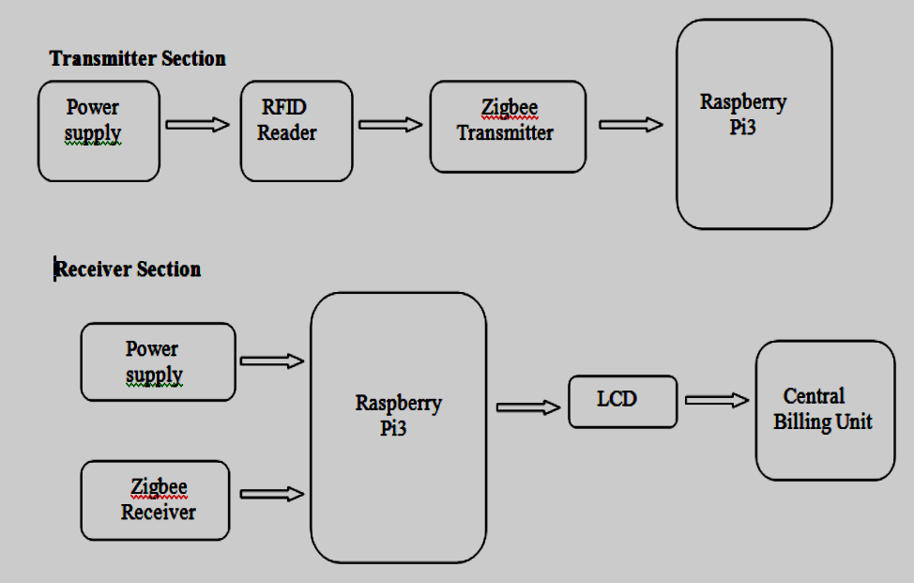

It shows the block diagram of proposed system in which reader is connected to Raspberry Pi which in turns gets connected to LCD and Zigbee which then sends billing information to Central Billing unit. At the transmitter section the reader detect the tags and sends the data to Raspberry Pi which then compares it with the data stored in it and displays on the LCD Screen attached to it.Thezigbee transmitter sends the information displayed on LCD. Zigbee receiver present at the Central Billing unit finally prints the data sent by the Zigbee transmitter.

**SYSTEM DESCRIPTION**

**CIRCUIT DIAGRAM**



**Circuit Design**

The Raspberry Pi board (Pi3) operates on 5.1 V which is supplied through USB from PC.

Input Power Pins 1 ,17 of LCD are connected to 1,17 pins of Pi which are 3.3V.

Positive Input power Pins 2,4 of LCD are connected to 2,4 Pins of Pins which are 5V, Pins 6,9,14,20,25 of LCD are connected to Ground pins of Pi.

Pins11,18,19,21,22,23,24,26 of LCD are connected to GPIO17,24,MOSI,MISO,GPIO25,SCLK,CS0,CS1 of Pi and Pins 3,5,7,8,10,12,13,15,16 of LCD are connected to SDA,SCL,GPIO4,UART0 TX, UART0 RX,GPIO’s 18,27,22,23 respectively.

2,3 Pins of two USB ports are connected to TXD and RXD of Reader and Zigbee respectively .

**Flowchart depicting the working of proposed model**

The flow chart of the proposed system is shown. It states that after initializing the system the reader will scan for RFID tags. If RFID tag is found reader reads the tag and sends the information to microcontroller which then compares it with data stored in memory. .If the tag matches with the data stored it will display data on the LCD. If items keep on adding it goes on adding to the total amount. If item from trolley is removed then it deducts cost of that specific item from total amount. Then after adding of items is done total amount is send to Central billing unit .

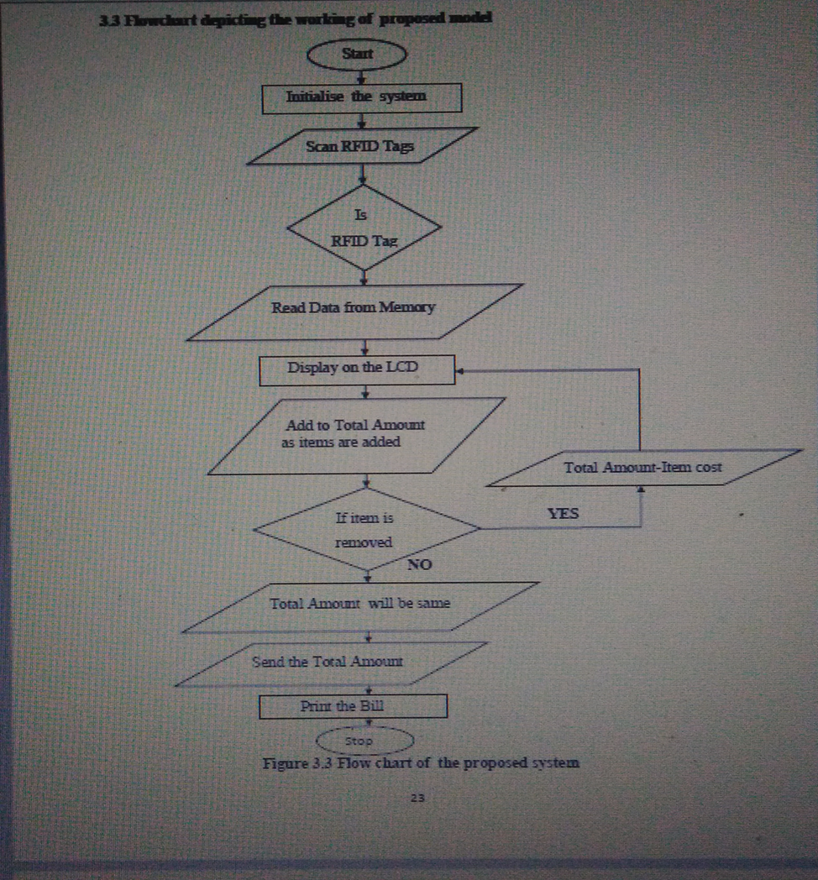

**WORKING**

* The proposed system in this will be implemented into two parts .
* First part is the initialization of the Raspberry Pi for the set up of RFID Reader and Zig bee .
* Second part is the tag detection of products by RFID Reader which are placed in the cart and sending of product information from cart to Central billing unit through Zig bee.
* The overview working of this system is - This proposed system works as on customer getting into the mall she/he first takes a trolley.
* Every cart is connected with a RFID reader ,a microcontroller and LCD screen. When the customer starts dropping products into the trolley, tags will be read by the reader and the reader sends the information to the microcontroller.
* The microcontroller compares the information with the data already stored in it. If the data matches then the cost of that product will be displayed on the LCD screen for user .
* If the user wish to remove any product from the cart then they can take away that product from trolley and cost of that particular product will be subtracted from the total amount instantaneously and after shopping the products data with total amount gets transmitted to the central billing system through zig bee.
* The RFID Reader will be placed in the mid position on the base/bottom inside the trolley. The cart is designed in such away that the outer part of the trolley will be covered with RF(Radiofrequency) shielding in order to make sure that the RFID reader will not read any products associated with tags outside the cart.

**HARDWARE SYSTEM CONNECTION**



**HARDWARE SPECIFICATIONS**

1. **RASPBERRY PI 3**

This is operated with 5.1V micro USB supply. Generally it usesamidst 700-1000mA depending on what peripherals are connected. The maximum power Raspberry Pi can use is 2.5Amp.The power requirements of the Raspberry Pi increasedepending on different interfaces attached to it. The GPIO pin uses 16mA safely, the HDMI port uses 50mA ,the camera module uses 250mA ,the keyboard and mice can take as small as 100mA or above 1000mA



**Technical Specifications**

Broadcom BCM2387 chipset

1.2 GHz Quad Core ARM Cortex- A5325

1 GB RAM

64 Bit CPU

4 x USB ports

4 pole Stereo output and Composite video port

Full size HDMI

10/100 Base T Ethernet Socket

CSI camera port

DSI display port

Micro SD port for loading your operating system and storing data

Micro USB power source

**Characteristics**

10x faster

Completely HAT Compatible

40 pin extended GPIO to enhance your real time projects

Streams High Definition Output at 1080.

**2.RFID Reader**

The RFID Reader selected for this project is uhf rfid of model YR9010. It’s dimensions are as 120x85x20mm. It works in the frequency range of 902 Mhz- 928 Mhz or either in the range of 865Mhz-868Mhz. It works with the voltage of 3.5V-5V and the output power will be in the scope of 0dbm-26dbm. It is a multiconnector and can communicate with the many interfaces like USB 2.0,RS232,Wiegand 26 and Wiegand 34. It can read up to 50 tags/sec depending on antenna, tag and application. It’s reading capability varies from 10cm-3m depending on tag, antenna and implementation. It has a communication baud rate of 115200bps(default) and operating current will be 180mA at 3.5V (26dBm output,25°C) andas 110mA at 3.5V (18 dBm output,25°C).It can be used as Desktop reader and also as a entryguard machine.



**Description of Reader pins**



**3.Touch screen LCD (Liquid Crystal Display)**

**Characteristics**

• 320x480 resolution

• Resistive Tap control

• Assists any model of Raspberry pi

• Drivers Provided (works with your own Raspbian/Ubuntu directly)

• Size flawlessly fits with Pi

• Excellent concentration of Gold Surface Plating

• Supports Raspbian system, equip your system

• Support Software keyboard( system interaction without keyboard/Mouse )

**Description of LCD pins**



**4. RFX240 Zigbee Module**

RFX240 is minimised to a greater extent to supply all suitability of transfer of power

intensification for IEEE 802.11b/g/n implementation in the 2.4GHz frequency range.It

produces a gain of 30db and a range of +26dbm of linear output power with low EVM of less

than 3percent for 802.11n MCS7 HT40 signals. It has argument control for CMOS, input

impedance matching for on chip along with mixed RF decoupling for the electricity supply. It

is constructed in a optimised 3.0x3.0mm 16L-QFN package. It requires less outward

elements to significantly make easier the RF Front end implementation.

In this project we have connected one zigbee to the USB port of Raspberry Pi and other

Zigbee to the USB port of PC which acts as Central billing unit.



**Features**

• Very Less DC power Consumption

• DC Decoupled RFports

• 50 ohm input/output matching

• Very less External Elements required

• Consistent with low voltage(1.2V) CMOS control logic levels or levels upto VDD

• High gain of 30db

• ESD Protection circuitry on all ports

• Mixed power indicator for transfer of power monitoring and control

• Great transfer signal proportionality meeting standards for OFDM/CCK Modulation.

• Inward RF decoupling on all VDD bias pins.

**Device Pin-Out**



**Description of Device pins**



**RFID Passive Tags**



Passive tags are also known as Battery less tags. Price per each tag may vary few cents to ten

or twenty euros depending on frequency, formfactor, packaging etc. This tags have no inward

power generators and are driven by the electromagnetic energy supplied from the RFID

Reader. The lesser price per tag makes availing RFID systems beneficial and inexpensive for

many industries.

Usually three main parts constitute an Passive RFID system. They are

i)RFID Reader

ii) RFID antenna and

iii) RFID tags

When Compared to active tags the standard passive tags have only two components.

They are:

i)Tag Antenna and

ii)Microchip or Integrated circuit(IC)

This standard structure is usually mentioned as RFID inlay.

As the name itself refers passive, these tags normally holdup for a signal from reader.

The Reader discharges energy to the antenna whereby the antenna converts that energy

into radiofrequency waves which are thereby sent to the readzone. After the tag getting

read with in the readzone ,the antenna which is present in passive tag gets energy from

the RF waves. The energy there from the tag antenna moves to chip and produces a

signal back to the system.This is called as backscatter. The backscatter or alter in

electromagnetic or RF wave is identified by the reader (through the antenna) which

interprets the data. Passive tags do not operate at all frequencies. Along with the frequency range there are many factors like readrange, materials attached ,type of application with the which the

working gets influenced.

**DESIGN OF SHOPPING CART**



**SOFTWARE DESCRIPTION**

**SETTING UP OF RASPBERRY PI 3**

First we need to boot Raspberry Pi ,for this when pi is powered up it tries to communicate to

an attached SD card and looks for a file called bootcode.bin; if it finds then it loads into

memory and leaps to it. This code then continues to load up the rest of the Pi system.

For dumping the code in to Raspberry Pi ,the process is as follows.



** FIG: WRITING CODE IN FILE**



**RUNNING THE FILE**

The main steps involved in testing of the system is:

• Sending data to the reader

• Receiving data from the reader

• Sending data to the reader: As the reader can understand only hexadecimal values,

an array of data is initialized to turn the antenna ON and send data i.e.;

request[7] = {0xA0,0X04,0X01,0X89,0X01,0XD1,0X00}; . Similarly, different arrays

of each tag were initialized and stored.

• Receiving data from the reader: As the reader receives the signal, it responds by

sending an array of data, the one which is stored in the buffer. For this project only

the unique ID of the tag is being stored in the program, which were read during the

reader configuration and tag testing process.



**GUI PAGE DISPLAY ON LCD**



**SHOWS HOW THE PRODUCT DISPLAYS ON LCD**



**DISPLAY OF PRODUCT LIST ON CENTRAL BILLING UNIT**



**Details display on screen how if one product for example drink is removed from**

**trolley. Removal of single product data on LCD**

**updated amount in the central billing unit if one product is removed**

